Title: DELETE EVERYTHING IN CAPS AND REPLACE WITH YOUR TITLE
Date: 2020-03-03 DELETE THE CAPITALIZED WORDS HERE BUT MAKE SURE THE DATE IS CORRECT AND FORMATTED CORRECTLY DIPSHIT
Category: Original Content DELETE THESE CAPITALIZED LETTERS TOO, DON’T CHANGE THE CATEGORY HERE
Author: REPLACE EVERYTHING IN CAPS HERE WITH YOUR PSEUDONYM / NAME (OPTIONAL)

Replace This With Article Title. Do not resize or create any other headers of the same size
If the header above isn’t clear, you’re deleting that header and replacing it with the title of your article. It should match the Title defined at the very top of the page. If it doesn’t I’m going to change one or the other to make them match. Make sure that the body of your article is in this font size.
Don’t try to include your author name in your google doc or bother too much with formatting outside of the defaults given here. Most of it is handled automatically by the tools I use to generate the website and may get overwritten.

Article subsection size (biggest)
This is another header, you don’t need these if you don’t want them but feel free if they provide organization. Below are some other sizes if you’d prefer. The

Article subsection size 2

Above is yet another header. Below is a picture.

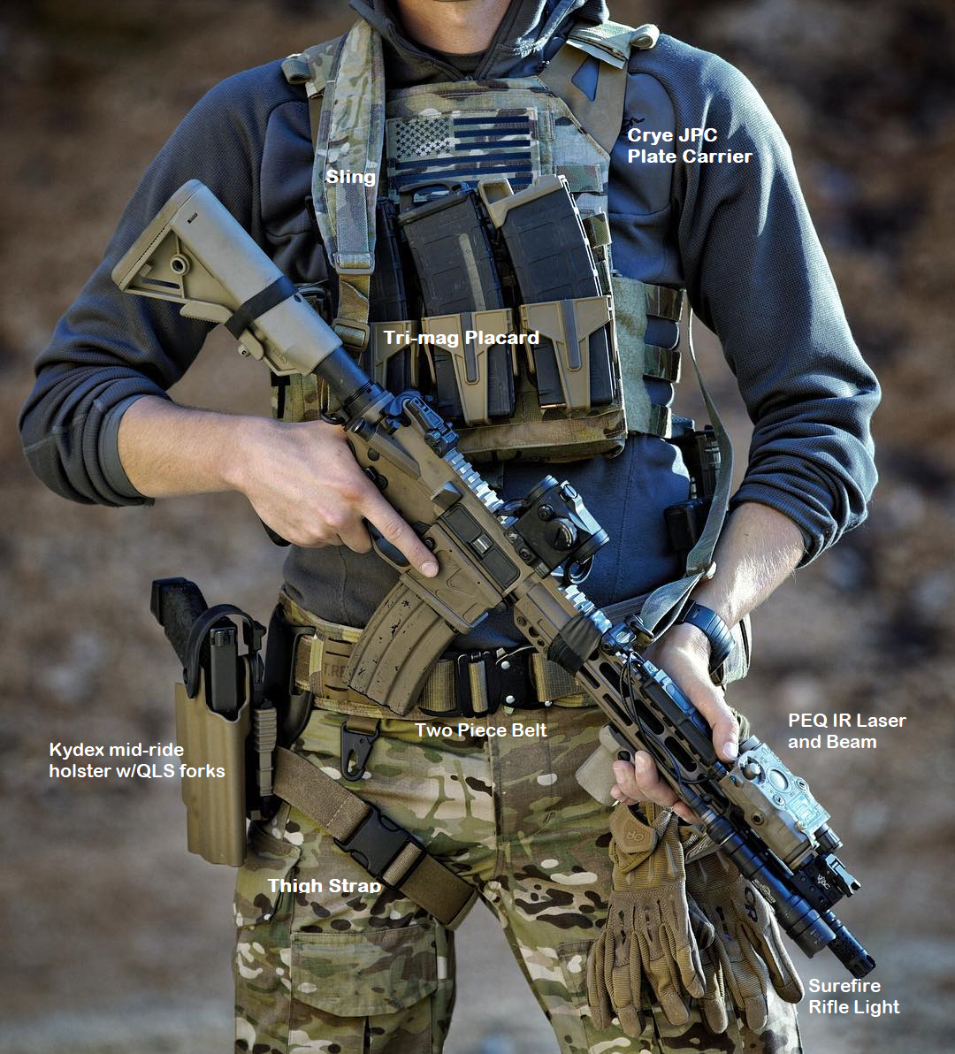
You should caption your image in italics like so if you plan on captioning it.

Article subsection size 3
By the way italics and bold are absolutely fine.

- Bullet
- Points
- Are
- Fine

- Numbered Lists
- Are also fine

Embedded links are fine

Article subsection size 4 (smallest)
I have no idea why you’d want to use this subsection size but whatever.

